

Semester One

Examination 2017

Question/Answer booklet

MATHEMATICS
METHODS UNIT 1

Section One:
Calculator–free

Student’s Name: _____________________________________
Teacher’s Name: _____________________________________

Time allowed for this section
Reading time before commencing work: five minutes
Working time for paper: fifty minutes

Material required/recommended for this section

To be provided by the supervisor
This Question/Answer booklet
Formula Sheet

To be provided by the candidate
Standard items: pens (blue/black preferred), pencils (including coloured), sharpener, correction tape/fluid, erasers, ruler, highlighters

Special Items: nil

Important note to candidates
No other items may be taken into the examination room. It is your responsibility to ensure that you do not have any unauthorised notes or other items of a non–personal nature in the examination room. If you have any unauthorised material with you, hand it to the supervisor before reading any further.

Structure of this paper

 | Number of questions available | Number of questions to be attempted | Working time (minutes) | Marks available | Percentage of exam
Section One  Calculator—free | 8 | 8 | 50 | 51 | 35
Section Two  Calculator—assumed | 13 | 13 | 100 | 99 | 65
 |  |  |  | 150 | 100

Instructions to candidates

- The rules for the conduct of Western Australian external examinations are detailed in the
Year 12 Information Handbook 2017. Sitting this examination implies that you agree to abide by these rules.

- Answer the questions according to the following instructions.

Show all your working clearly. Your working should be in sufficient detail to allow your
answers to be checked readily and for marks to be awarded for reasoning. Incorrect answers given without supporting reasoning cannot be allocated any marks. For any question or part question worth more than two marks, valid working or justification is required to receive full marks. If you repeat an answer to any question, ensure that you cancel the answer you do not wish to have marked.

It is recommended that you do not use pencil, except in diagrams.

- You must be careful to confine your responses to the specific questions asked and to follow any instructions that are specific to a particular question.

- Spare pages are included at the end of this booklet. They can be used for planning your responses and/or as additional space if required to continue an answer.
- Planning: If you use the spare pages for planning, indicate this clearly at the top of the page.
- Continuing an answer: If you need to use the space to continue an answer, indicate in the original answer space where the answer is continued, i.e. give the page number. Fill in the number of the question that you are continuing to answer at the top of the page.

- The Formula Sheet is not handed in with your Question/Answer Booklet.

Section One: Calculator–free 35% (51 marks)

This section has eight (8) questions. Attempt all questions. Write your answers in the spaces provided.

Spare pages are included at the end of this booklet. They can be used for planning your responses and/or as additional space if required to continue an answer.

- Planning: If you use the spare pages for planning, indicate this clearly at the top of the page.
- Continuing an answer: If you need to use the space to continue an answer, indicate in the original answer space where the answer is continued, i.e. give the page number. Fill in the number of the question(s) that you are continuing to answer at the top of the page.

Working time: 50 minutes

Question 1 (5 marks)

(a) Describe the shaded region in set notation. (2 marks)

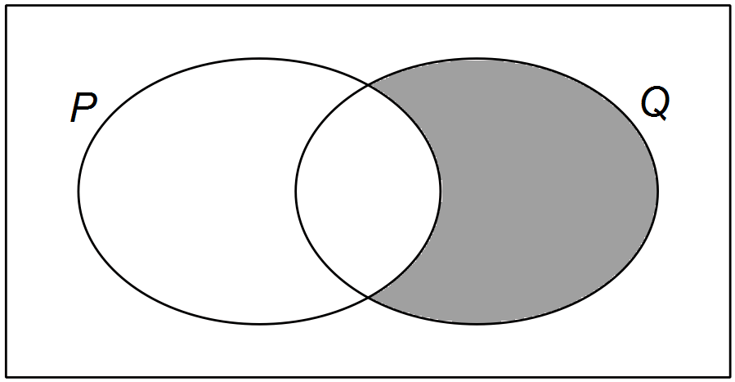 (i)

______________________

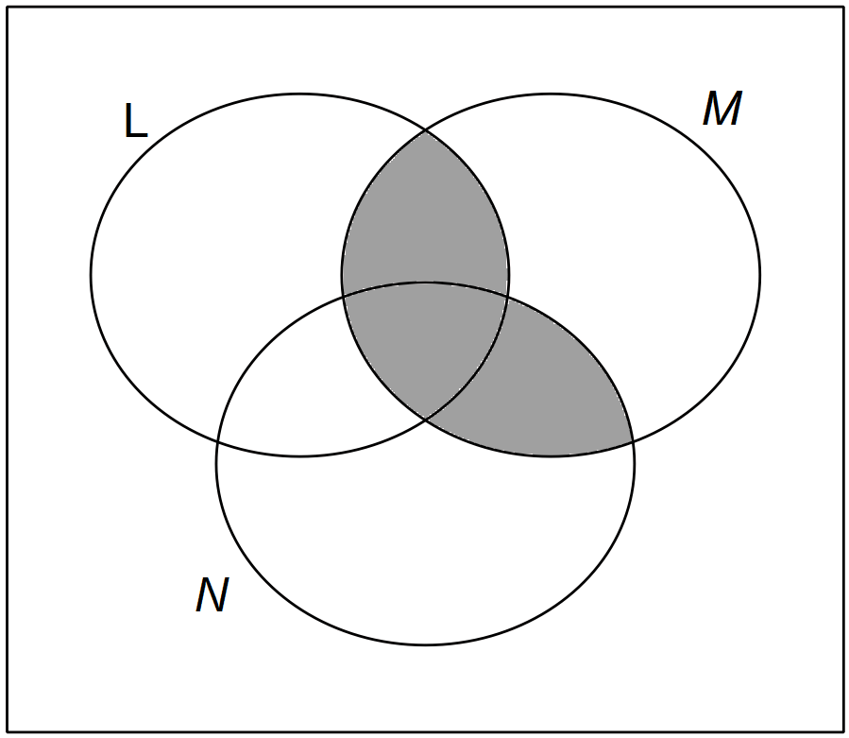 (ii)

______________________

(b) U = {positive integers between 1 and 20, where 1 and 20 are not included}
A = {prime numbers less than 19} B = {factors of 12} C = {multiples of 3}
State the following:

(i)  (1 mark)

(ii) 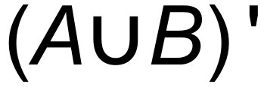 (1 mark)

(iii) 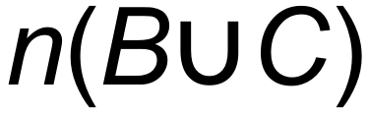 (1 mark)

Question 2 (11 marks)

Consider the functions graphed below.
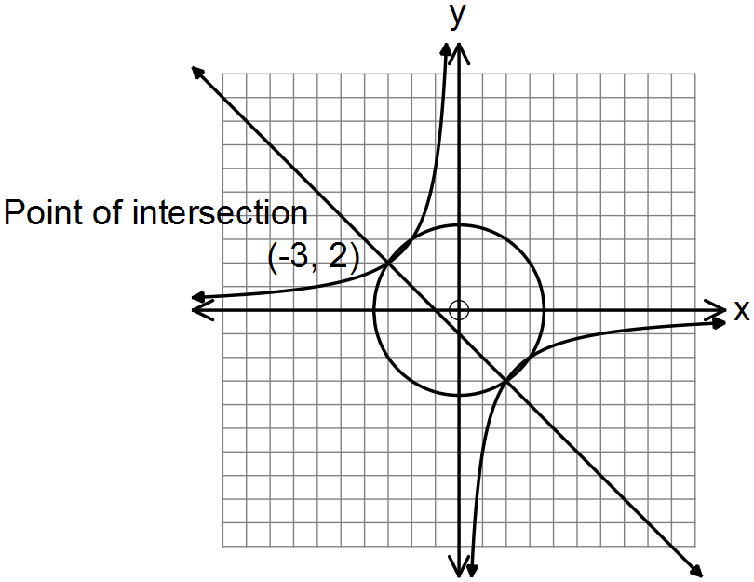

(a) State the equation for:

(i) 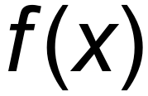, the circle with centre at the origin. (2 marks)

(ii) 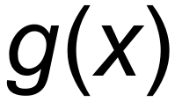, the hyperbola. (2 marks)

(iii) 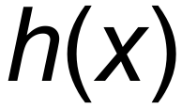, the straight line. (2 marks)

(b) Hence, solve the equation 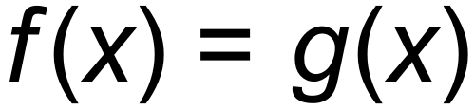. There are four solutions. (2 marks)

(c) The graph  undergoes the following transformation 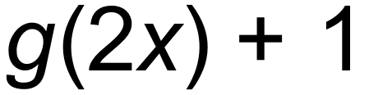.

(i) State the coordinates of the point (–3, 2) after this transformation has occurred.
(2 marks)

(ii) The graph  undergoes the same transformation namely 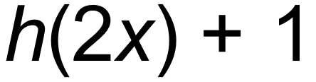. State the gradient of the transformed function. (1 mark)

Question 3 (4 marks)

A circle with the equation 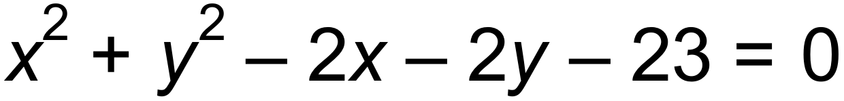 has a diameter MN. Find the coordinates of M if N is the point (4, 5).

Question 4 (6 marks)

(a) Find the exact value of . (2 marks)

(b) Use the sum of two angles to find the exact value of 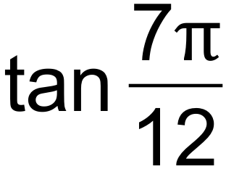 .
Rationalise the denominator of your solution. (4 marks)

Question 5 (7 marks)

Consider the triangle, which is not drawn to scale, shown below.
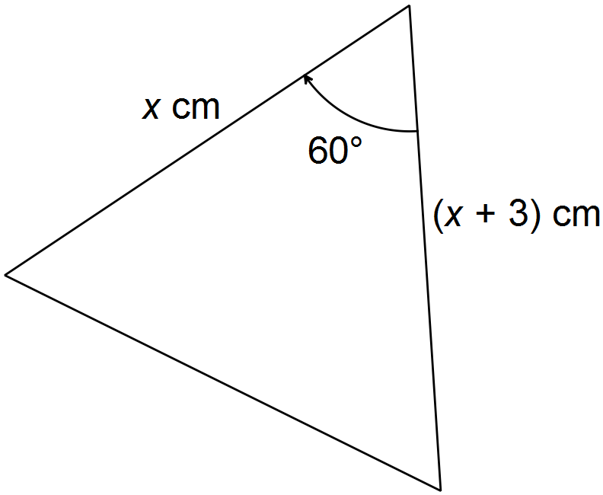

(a) Show that the area of the triangle is given by 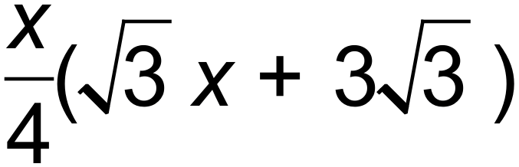 cm². (2 marks)

(b) Given that the length of the unmarked side is 7 cm, find the value of x. (3 marks)

(c) Hence, or otherwise, find the exact area of the triangle. (2 marks)

Question 6 (5 marks)

A doctor wishes to tell her patient’s family the probability of his condition improving after a certain treatment. Suppose I is the event that the patient’s condition improves, O is the event that his condition remains the same and W is the event that his condition worsens.
If P(W) = 30% and P(O) = 10 % find the probability that the patient’s condition:

(a) improves. (1 mark)

(b) does not improve. (1 mark)

(c) improves or stays the same. (1 mark)

(d) Draw a Venn diagram which shows that these three events are mutually exclusive. (2 marks)

Question 7 (8 marks)

The graph below can be written k(x) = 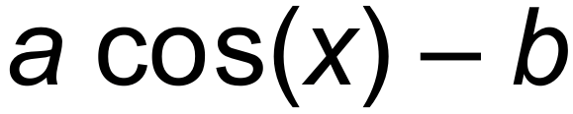 = 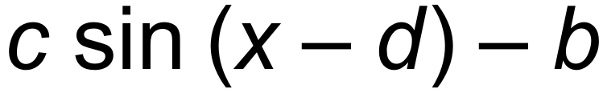

(a) Determine the values of a, b, c and d. (4 marks)

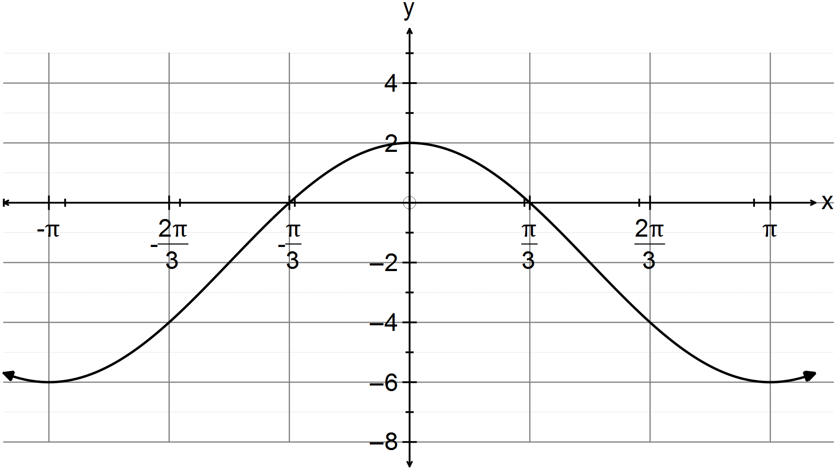

(b) Sate the range of k(x). (2 marks)

(c) Explain why the graph represents a function and verify your explanation by
using the vertical line test on the graph. (2 marks)

Question 8 (5 marks)

Solve for all values of 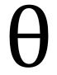 in the given domain.

(a) 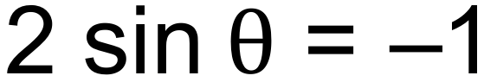 where 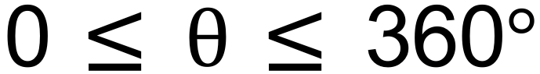 (2 marks)

(b) 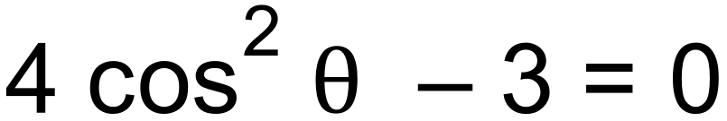 and 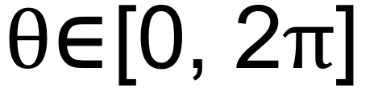 (3 marks)

End of Questions
Additional working space

Question number(s): ……………………

Additional working space

Question number(s): ……………………

WATP acknowledges the permission of School Curriculum and Assessment Authority in
providing instructions to students.

